

SUBJECT: DESIGN OF EMBEDDED SYSTEMS

PROJECT TITLE: Model based design for Speed control of DC motor using PID Controller

Team mates :

B Sai Soumith [PES1UG20EE081]

Lakshmibai [PES1UG20EE083]

Pratiksha[PES1UG20EE077]

B Sahithi Reddy[PES1UG20EE080

**SPEED CONTROL OF DC MOTOR:**

A DC motor is an electrical machine that converts electrical energy into mechanical energy. They play an important role in energy conversion process. We come across speed control of electric motors everywhere in a modern society. The list of speed control comprises a wide range of appliances, beginning with household electrical appliances used in the garden and garage, and ending with large industrial plants with conveyor belts, pumps and machine tools

**Purpose of electronic speed control in dc motor**

it is used to influence the rotational speed of motors and machinery. This has a direct effect on the operation of the machine and is crucial for the quality and the outcome of the work. When drilling, different rotational speeds must be selected for different materials and for various drill sizes, and in pump installations, the throughput rates must vary, and a conveyor belt must be able to adapt its speed to the workflow. Hence, its really important to control speed of motors

**CLOSED LOOP SYSTEM:**

A closed loop control system is a mechanical or electronic device that automatically regulates a system to maintain a desired state or set point without human interaction. It uses a feedback system or sensor.

In a closed loop system, the transfer function defines the mathematical relationship between the input and the output.

**PID CONTROLLER**

The term PID stands for proportional integral derivative and it is one kind of device used to control different process variables like pressure, flow, temperature, and speed in industrial applications. In this controller, a control loop feedback device is used to regulate all the process variables PID control is a feedback mechanism used in a control system.

Two main methods to control the speed of dc motor

a)Controlling the voltage manually:

b) Controlling the PWM using PID:

In a PID Algorithm, the current speed of the motor is measured and compared with the desired speed. The error is used in complex calculations to vary the duty cycle of the Motor with respect to time.This process occurs in every cycle. If the speed is more than the desired speed, the duty cycle is reduced and if the speed is less than the desired speed, the duty cycle is increased. This adjustment is made until an optimum speed is reached. This speed is continuously checked and controlled.

**APPROACH:**

a closed loop PID controller is used for controlling speed of dc motor. The sensor output(tachometer) is connected to a Low pass ﬁlter to remove the debouncing that is caused by the transients produced when the state of the sensor changes.Tachometer is used to measure rotation speed of a disk in the motor. The required reference speed is fed to the comparator along with signal from low pass filter.Later the signal,after passing through PID controller is passed through saturation block in order to limit the signal to a specific range.

**MODEL BASED DESIGN:**

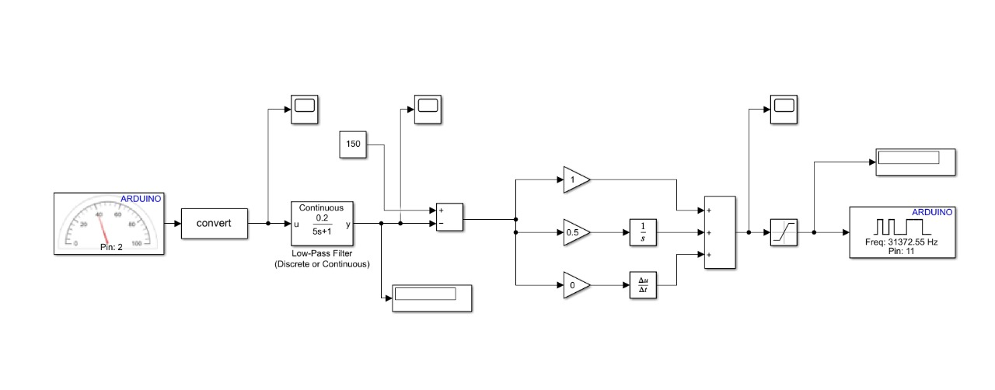

**Hardware implementation:**

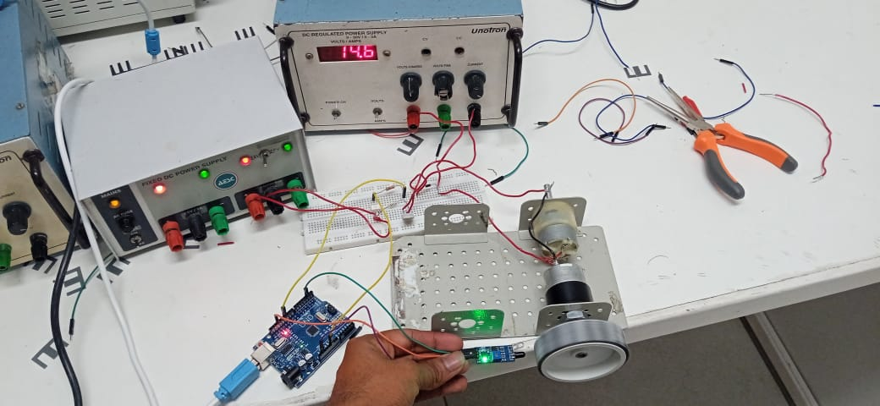

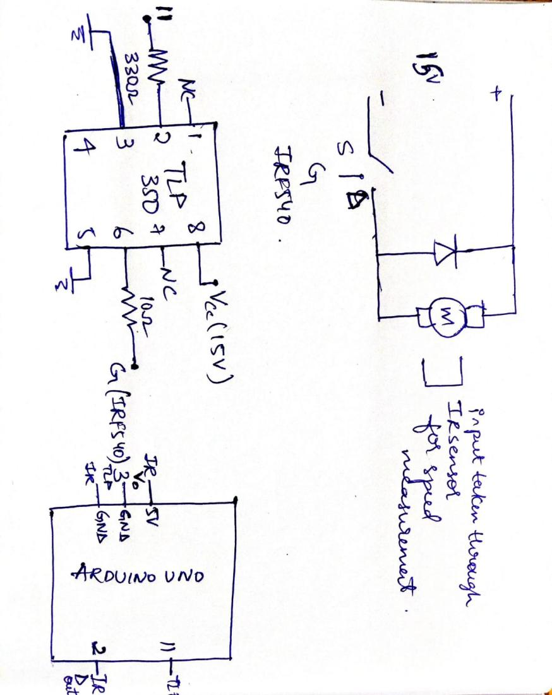

TLP350: (details taken from datasheet):

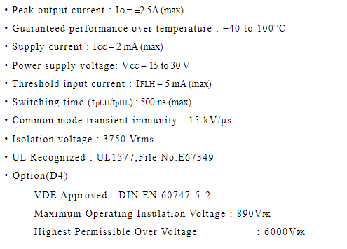

IRF540 :(details taken from datasheet)

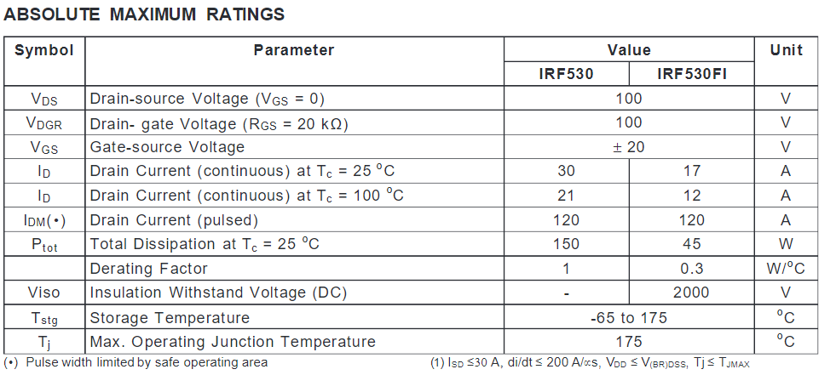

Output : the pid controller is used for maintaining the speed of the motor.